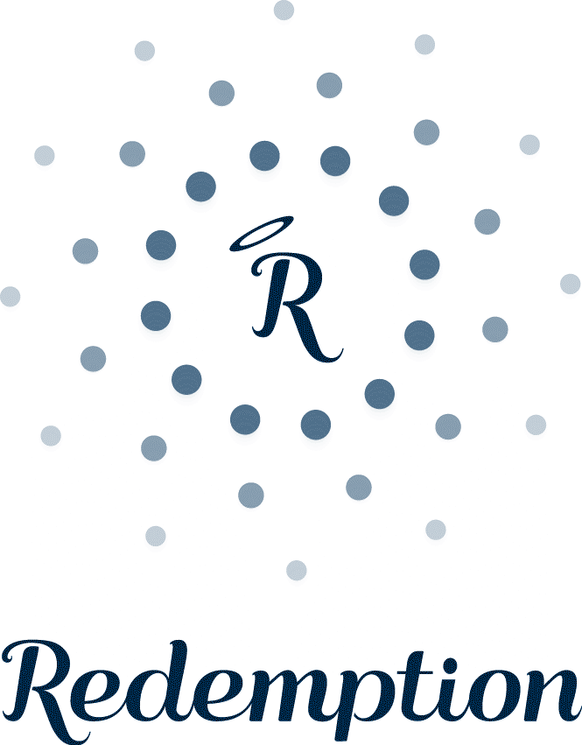

evening menu

nibble board £5.95
our delicious healthy nibble board with mixed olives, kale crisps and roasted nuts

soup of the day £6.95
a fresh and nutritious soup with our home made gluten-free sunflower and flaxseed bread

blue corn chips, turmeric hummus & beetroot dip £7.95
organic, GMO-free corn chips with a lemon, turmeric hummus and beetroot sunflower seed dip

grilled aubergine & tahini £9.50
caramelised aubergine with a miso glaze topped with toasted pine nuts, pomegranate seeds, sesame seeds and fresh micro basil

maki rolls platter £12.50
a gorgeous platter of maki rolls filled with quinoa, avocado, enoki mushroom, shitake mushrooms, chives, and toasted sesame seeds with wasabi and micro red amaranth

pulled barbecued ‘pork’ jackfruit & summer slaw £12.95
slow cooked jackfruit in sweet ‘n’ smoky barbecue sauce in a gluten-free bun served with summer rainbow slaw and roasted sweet potato wedges

tokyo salad £12.95
a nourishing brown rice and avocado salad with cucumber, radish, chilli, hijiki seaweed, a citrus-miso dressing and a sprinkling of sesame seeds

zucchini pasta con pesto £14.00 ®
raw courgette spaghetti tossed in basil and pumpkin seed pesto, rocket and cherry tomatoes, topped with brazil nut ‘parmesan’

asparagus & spinach black rice risotto £14.50
asparagus, spinach and peas black rice risotto topped with salsa verde, pecan nut ‘parmesan’ and rocket

temple of ten £15.00
the complete ten a day bowl! Kale, red cabbage, carrots, peppers, mange tout, cauliflower, purple sweet potato, spinach, cucumber and mushrooms with chickpeas and a spicy peanut sauce.

sides

rainbow asian salad £4.50 ®
red and white cabbage, fennel, carrot, peppers, pineapple and spring onion with a sweet chilli dressing

kale salad £5.50 ®
finely chopped kale salad with medjool dates, chili, sesame seeds, spring onions and almonds, tossed in a tamari sesame dressing

baked sweet potato & sumac £5.75
with coconut yoghurt, spring onions and pomegranate seeds

sweet treats

bliss balls £5.75 ®
packed with antioxidants, raw dark chocolate and date truffles rolled in coconut

rhubarb & ginger fool £6.00
pink English rhubarb poached with ginger and folded into creamy coconut yoghurt

lime cheesecake £6.50 ®
zesty lime cheesecake made from cashew nut cream, vanilla and coconut oil on an almond and sprouted buckwheat base, drizzled with raspberry coulis

banoffee pie £6.95
a chewy nutty chocolate base with medjool date salted caramel, banana and coconut cream

® = RAW = NOT COOKED ABOVE 42°

ALL MENU ITEMS ARE VEGAN, WHEAT-FREE AND LOW IN NATURAL SUGARS

ORGANIC WHERE POSSIBLE

WE USE NUTS!

SPOIL YOURSELF WITHOUT SPOILING YOURSELF

A DISCRETIONARY SERVICE CHARGE OF 12.5% WILL BE ADDED TO YOUR BILL

