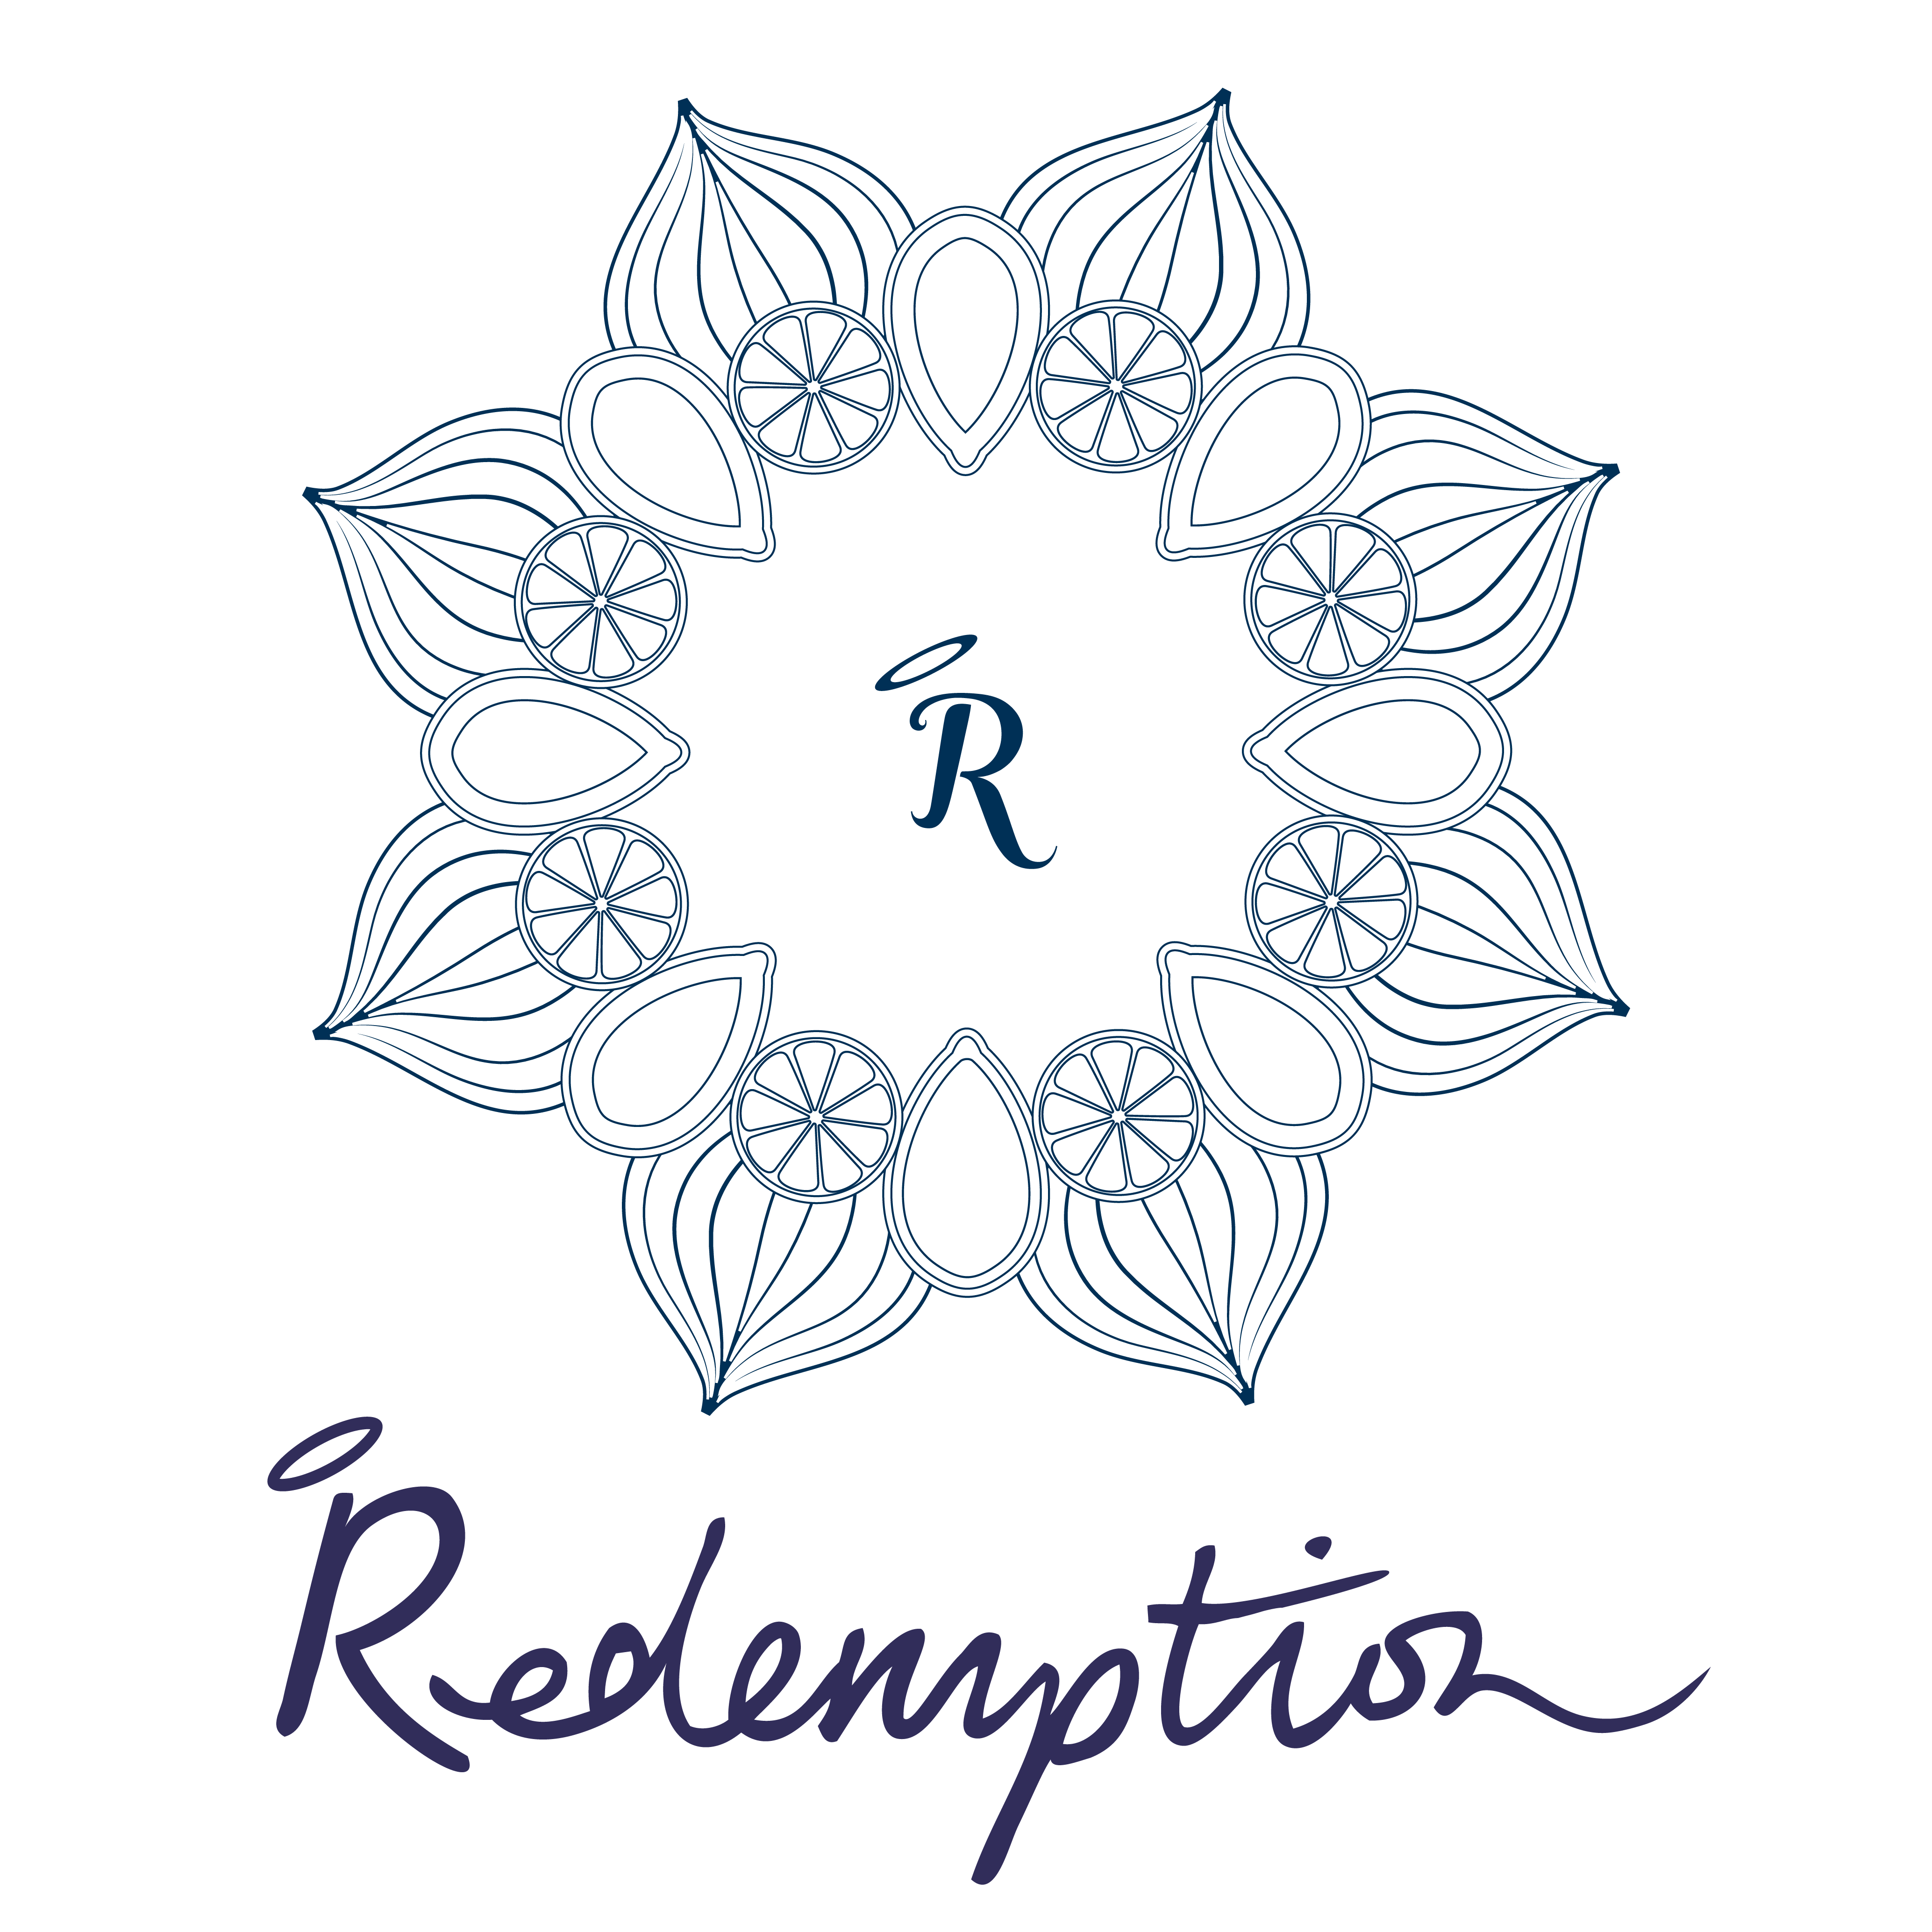

SPOIL YOURSELF WITHOUT SPOILING YOURSELF

evening menu

nibble board £5.95
our delicious healthy nibble board with mixed olives, kale crisps and roasted nuts

soup of the day £6.95
a fresh and nutritious soup with our home-made gluten-free sunflower and flaxseed bread

blue corn chips, lemon hummus & guacamole £7.95
organic, GMO-free corn chips with lemon turmeric hummus and fresh guacamole

brown rice penne pasta £9.75
organic gluten-free penne with a rich slow cooked tomato and red pepper sauce with black olives served with wild rocket and roasted pecan ‘parmesan’

grilled aubergine & tahini £9.75
sticky baked white miso and sesame glazed aubergines, served with creamy lemony tahini dressing and toasted pine nuts, pomegranate seeds and micro basil

maki rolls platter £12.75
a gorgeous platter of maki rolls filled with quinoa, avocado, enoki mushroom, shitake mushrooms, chives, and sesame seeds, with wasabi and micro red amaranth

jackfruit rendang coconut curry £12.50
a rich Southeast Asian-style dish with young jackfruit, fresh turmeric, ginger, lime leaf, cinnamon sticks and coconut milk served with black rice and a piquant pickled carrot and cauliflower kimchi

pulled barbecued jackfruit & superslaw £12.95
slow cooked jackfruit in sweet n’ smoky barbecue sauce in a gluten-free bun served with sauerkraut superslaw and roasted sweet potato fries

buff burger £12.95
love burgers…but love your body? Stay buff with our protein packed fibre-boosting shitake mushroom, black bean and ruby beet burger in a gluten-free bun with tomato, lettuce, caramelised red onion marmalade and sweet potato fries

probiotic booster bowl £14.50
aid digestion and boost your immunity with our green cabbage, celeriac, carrot and kolrabi superslaw with coconut kefir dill dressing, chopped kale salad with medjool dates, chili, sesame seeds, spring onions, almonds and a miso dressing, and a pickled carrot and cauliflower kimchi

wild mushroom & black rice risotto £14.75
earthy umami chestnut, shitake and porcini mushrooms folded into a black nerone risotto topped with salsa verde, pecan nut ‘parmesan’ and rocket

sides

probiotic superslaw £4.75 ®
aid digestion and boost your immunity with our green cabbage, celeriac, carrot and kolrabi superslaw with coconut kefir dill dressing

kale salad £5.50 ®
finely chopped kale salad with medjool dates, chili, sesame seeds, spring onions and almonds, tossed in a miso, sesame dressing

baked sweet potato fries & sumac £5.75
with coconut yoghurt, spring onions and pomegranate seeds

sweet treats

bliss balls £5.75 ®
rich and smooth raw dark chocolate and medjool date truffles rolled in coconut, divinely decadent whilst being packed with natural antioxidants

banana & walnut bread £5.95
heavenly warm and nutty gluten free banana bread with coconut yoghurt and a drizzle of maple syrup

seasonal cheesecake of the day £6.50 ®
we like to experiment with fresh and fruity seasonal creations - we know you’ll love our specials as much as we do…ask what awesome creations are available today!

banoffee pie £6.95 ®
a chewy nutty chocolate base with sticky medjool date salted caramel, bananas and coconut cream

® = RAW = NOT COOKED ABOVE 42°

ALL MENU ITEMS ARE VEGAN, WHEAT-FREE AND LOW IN NATURAL SUGARS

ORGANIC WHERE POSSIBLE

WE USE NUTS!

A DISCRETIONARY SERVICE CHARGE OF 12.5% WILL BE ADDED TO YOUR BILL

